Mangroves for the Future (MFF) initiative

Mangroves and Climate Change Component
Review Workshop
Ho Chi Minh City, 01-02 June, 2015
Economic Studies for management decision making: case study from Bangladesh
Dr. A.K. Enamul Haque
Asian Center for Development
Background
Natural landscapes such as forests, grasslands, mangroves and wetlands, as well as agro-ecosystems, provide a range of services that sustain and enhance human welfare. These may be in the form of provisioning services such as food, water, timber, fiber and genetic resources; regulating services such as regulation of climate, floods, drought, land degradation, water quality and disease prevention; supporting services such as soil formation, pollination and nutrient cycling; and cultural services such as recreational, spiritual, religious and other non-material benefits.
Political, economic and societal support for conserving ecosystems and promoting sustainable agro-ecosystems can be considerably increased if the value of ecosystem services to society can be highlighted and incorporated into land-use management and policies using economic and legal instruments. However, ecosystem services are complex in their attributes, spatial patterns and dynamics.
Furthermore, ecosystem services have trade-offs and synergies which differ with spatial and temporal scale and that makes sustainable management of diverse ecosystem services for different stake-holders complex. The role of biodiversity in stabilizing ecosystem functions and services at various spatial and temporal scales is still not fully understood. The role of climate and other global change on the future dynamics and resilience of ecosystem services and impacts on local communities and livelihoods is largely unknown and is required for climate change adaptation and mitigation.
South Asia, which supports over 1.2 billion people, has complex ecosystems and social and political dynamics and interactions with these systems. Yet, ecosystem services are not seriously recognized in official discourse. For example, national strategies on climate change and water are yet to incorporate the latest thinking and concepts related to ecosystem services. Emerging challenges such as the threat of land-use change on biodiversity, crisis in agriculture and water sectors with implications for inter-region water sharing, and the rapid change in coastal landscapes decreasing our resilience to climatic changes, could potentially benefit from a better articulation of the scientific underpinning, challenges to and the practical implications of managing ecosystem services for sustainable development. There are many trade-offs made related to resource use that affect ecosystem services on a regular basis, which in turn have implications for human welfare. Thus, identifying and understanding the reasons underlying these trade-offs, crafting appropriate institutions and examining the benefits from ecosystem management is important.
Objective(s)
In order to understand the trade-offs between ecosystem services and economic use of mangrove and coastal ecosystems, MFF decided to conduct a series of researches to create evidences for sustainable management of mangrove and coastal ecosystem services. It was hoped that an evidence based research would be able to promote such strategies.
Study Area and/or Scope of Work
In order to ensure that the evidences created through research are methodologically sound and robust, the Asian Center for Development floated a ‘Call for Research’ in January. The Call was also circulated among members of SANDEE using a SANDEE (South Asian Network for Development and Environmental Economics) listserv to researchers in Bangladesh who were active in research and were trained on Environmental Valuation. In addition, we also sent emails to a selected group of SANDEE researchers.
Researchers responded to the call through emails and telephone calls. It was clearer that a dialogue between MFF Secretariat in Bangkok and with interested researchers are required in order to streamline the research topics without which the research ideas could be away from the relevant policy focus of MFF.
A scoping meeting was arranged via Skype and it was moderated by Dr. A.K. Enamul Haque, Advisor to SANDEE and Director of ACD in order to develop specific policy focus from these studies. The scoping meeting was an interesting addition to the process and it lasted for 2 hours.
Based on the scoping meeting, four specific research themes were developed. These are:
a. Economics of Crab Production: Mud crab harvesting has been gaining popularity in coastal areas near Sundarban and it has become an important export item from Bangladesh. The process of mud-crab harvest involves several layers of agents starting from catchers to the exporters. The objective of the research is to understand i) the value chain of mud-crab exports and identify the major players in the industry, and ii) analyze the impact of mud-crab harvest on the ecosystem using Maximum Sustainable Yield estimates.
b. Impact of Small Grants Facilities of MFF: MFF provided Small Grant Facility (SGF) supports to local community-based actions for the conservation and management of coastal ecosystems with the objective to realize the potential of mangroves and other coastal vegetation for climate change adaptation and mitigation. The main aim of the SGF is to finance small projects to support strategic local community action for management of coastal ecosystems and their use on a sustainable basis. Over the period of years, such activities in coastal areas were able to galvanize coastal communities to protect the mangroves as they began to realize the value of such actions. The objective of the research is to create evidences in terms the impacts of SGFs to promote conservation of mangroves and to reduce vulnerability of coastal communities against potential threats of climate change.
c. Cost Benefit Analysis of Sylvo-fisheries: Mangroves in Chittagong regions of Bangladesh were completely depleted due to systematic rise of shrimp farming in coastal areas in Chakaria. The Chakaria mangroves were naturally grown mangroves and due to expansion of shrimp farming through both resettlement of population and leasing of land for shrimp farming, the mangroves forest lands were completely denuded by the end of the 90s. However, over time, shrimp farming also became less productive and soil salinity increased. Many areas were replaced by salt farming. However, MFF activities in Vietnam provided an incentive to MFF Secretariat to study the economics of sylvo-fisheries.
d. Economics of Ban on Timber Collection: Government of Bangladesh banned collection of timber from all forests including the mangroves in 1989. After 25 years of this ban, many policy makers are questioning the effectiveness of such ban in terms of protecting the forests. It was realized that without providing alternatives in terms of livelihood to the people dependent on forests, such ban has been failing. The objectives of such study could be to understand the policies required to conserve the forests.
Methodology
Based on the discussions, ACD received 4 proposals on these themes from SANDEE researchers in Bangladesh. ACD with support from SANDEE resource persons reviewed the proposals in terms of clarity, methodological consistency and objectives of the research. Based on the comments, ACD organized a Research and Training Workshop in Colombo on 24-25 February 2015 where researchers, resource persons and MFF teams from several other countries attended.
The Two-day deliberations helped researchers to make the studies more focused and methodologically robust. They were then requested to revise their proposals and submit to ACD for a final review.
Researchers used feedback during the workshop, discussions with IUCN office in Dhaka and also local feedback from key informants to further refine and submit their proposals to ACD.
ACD reviewed the proposals using resource persons or mentors attached to each research team to finalize the final research proposals. This is shown in the following diagram.

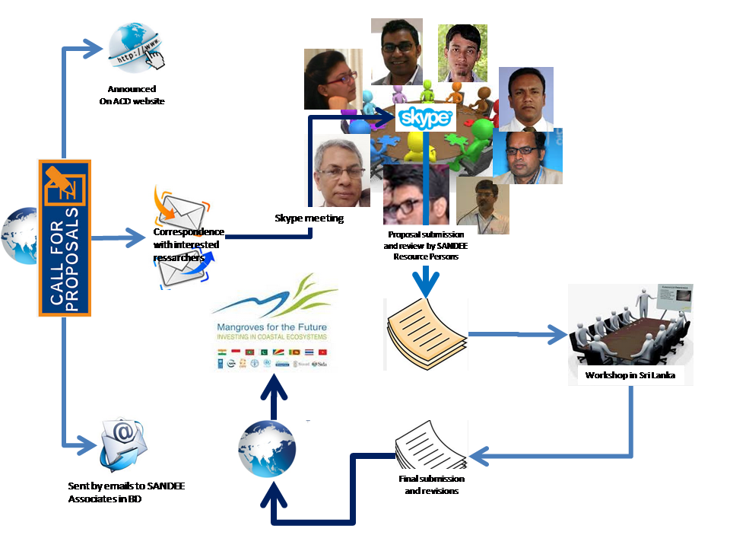
Based on the feedback from ACD, MFF Secretariat in Dhaka finally contracted three research teams for studies.
Results
The three teams and their research topics are:
Team 1: Value Chain and Sustainability of Wild Mud Crab Collection: a provisional ecosystem service from mangroves in the South-west Coastal Region of Bangladesh – by Dr. Muhammand Ziaul Haider, Department of Economics, Khulna University (with Fariha Farjana).
This study is mentored by Dr. A.K. Enamul Haque (ACD) and Dr. Santadas Ghosh (Vishwavarti, West Bengal).
Team 2: Analyzing the Effectiveness of MFF-SGF Program on Household and Community Resilience to Climate Change in Bangladesh by Ms Suzana Karim, Institute of Health Economics, Dhaka University (with Moinuddin Ahmed and K M Nafiz Iftekhar)
This study is mentored by Dr. A.K. Enamul Haque (ACD) and Dr. Saudamini Das (Institute of Economic Growth, New Delhi)
Team 3: Economic Feasibility of Sylvofishery in Charakria Sundarban, Bangladesh by Dr. Mahfuzur Rahman, Institute of Forestry, Chittagong University (with Dr. Muhammed Kamal Hossain, and Dr Mohammad Mosharraf Hossain).
This study is mentored by Dr. A.K. Enamul Haque (ACD) and Dr Heman D Lohano (SANDEE).
Achievements
All the three studies are now fielded. Researchers have developed the questionnaires for data collection with support from their mentors and have started collecting data.
The studies are expected to be completed by the end of June 2015.

Lessons Learned
Expected lessons from research studies
The research study results are yet to be known. Therefore, it is difficult to given an conjecture on the findings. However, there are some expectations for us on the outcome of the researches.
The first study on Mud Crab is expected to shed light on the value chain of the business. This value chain can be analyzed to understand whether mud-crab farming can be profitable through aquaculture and if it does then a strategy to promote mud-crab farming instead of the current capture method of harvest can be developed. At the same time, the research is expected to provide estimate of MSY which can be used to limit open access catch of mud-crab to ensure sustainable management of this resource. The study is also expected to identify the threats on the current stock of resources available in Sundarban forests. The study specifically aims at:
Addressing the future threats on mud crab species for continuous harvesting of natural resource by mud crab collectors. It will also focus on developing a sustainable harvesting policy for wild mud crab from the mangroves. This study will also try to trace out alternate income generating activities of the wild mud crab catchers which might be helpful to reduce the intensity of mud crab harvesting and protect the ecosystem of mangrove from further damages.
The second study is on effectiveness of SGF activities would help policy makers to understand how a community based intervention could be steered to reduce vulnerability of peple from climate threats. Specifically, the study aims to:
Assess the effectiveness of SGF on generating supplementary livelihood options, the sustainability of these livelihood options, the impact of SGF on capacity building and climate change adaptation strategies, and identify the impact of the programs on the communities, also to find unintended effects, if any, that may have emerged due to the programs. Results of this study can be used to replicate programs related to climate change adaptations.
The third study on sylvofishery is unique in nature. It complements the team of ecological experts’ findings in terms of promoting shrimp-crab farming in conjunction with expansion of mangrove forests. The study uses economic cost benefit analysis to find out what policies are needed to regenerate forests in a degraded forest land. Specific objectives of the study are to:
Examine the financial feasibility of sylvofishery, evaluate the economic feasibility of sylvofishery in Chakaria Sundarban, and test the ecological feasibility of integrated sylvofishery in degraded forest lands.
Other lessons
While the results from the study are yet to be found, initial findings from the field is encouraging. Researchers are hopeful of developing a set of policy prescription from these studies. However, the exercise provided the following lessons for MFF team.
a. Ecosystem valuation studies need to be initiated with care – Freelance researchers often miss out on the policy relevance of studies. It is, therefore, important to use a dual approach to ensure that studies are scientific, evidences are robust and policy interventions are relevant. The approaches are: a) engage a strong group of mentors for ensure quality of the study, b) engage program personnel to keep the studies focused in terms of government policies and other ground realities.
b. Research and Training workshop in presences of a heterogenous groups helps researchers to re-negotiate the focus of the studies.
c. Presence of stronger resource persons and mentoring helps young academics to develop sound methodology for research.
Recommendations and Next Steps
Once completed the three studies will help MFF understand their impact and determine their future strategies for both replication and refinement of their programs. This is a cost-effective approach to evaluate complex projects.
Key References
Project Work Progress Report from the Asian Center for Development. Submitted on April 1, 2015.
Research Proposals submitted to IUCN by the Researchers.

