Workshop Report
Developing Methodologies for The Valuation of Ecosystem Services

Organized by:
UWIFoRT-DOFPS, Bhutan
Bhutan for Life
ICIMOD

Bumthang, Bhutan
9-13 September, 2023

Signature:
Submitted by: …………………………………….
Date: …………………………

- Background of the visit
Ecosystems are multi-functional and provide a wide range of services that are essential for the sustainable development of human societies. Valuation of the ecosystem’s services or nature’s contribution to people is a very useful tool for policymakers and managers of ecosystems to determine management priorities, balance the interests of stakeholders and design incentive mechanisms for ecosystem management.
To guide national conservation planning and investment, the Department of Forests and Park Services, Bhutan through its multiple-year programme Bhutan for Life, intends to estimate the value of the ecosystem services of all its protected areas and biological corridors using appropriate and established methodologies. Ecosystem services valuation for the Chamkharchhu Basin has been prioritised in the current fiscal year. The purpose of the valuation is to estimate the economic values of the ecosystem services that the Chamkharchhu River Basin generates, which then helps the government for making informed decisions on the alternative uses of the river system.
Thus, the UWIFoRT-DOFPS, Bhutan for Life, and ICIMOD jointly organised the workshop with technical SANDEE to build the capacity of officials and researchers from Bhutan on the valuation of ecosystem services.

- Visit Purpose
The purpose of the visit was to:
- Build capacity of staff from partner institutions in Bhutan on ecosystem services valuation
- Develop standardised methodologies for the valuation of ecosystem services of the Chamkharchhu River Basin to be implemented by UWIFoRT, DOFPS supported by Bhutan for Life
- Built the capacity of the Bhutan team to carry out a valuation of ecosystems services starting from the Chamkharchhu River Basin, and then expanding to all the National Parks in Bhutan.
- Methods developed of different ecosystem services valuation for use in the Bhutan’s context led by UWIFoRT, and DOFPS by assisting to frame specific questions and parametric measurements and variables of ecosystem services for valuation.

- Key accomplishments observed:
The 5-day workshop was successful in imparting the theoretical concepts of ecosystem services valuation, work on building proposal for ESS valuation in real-case scenario, and learn the basic of the statistical tool STATA. The major accomplishments made were:
- The four resource persons from SANDEE delivered the theoretical concepts on ecosystem services valuation, covering the following topics:
- Basics of ecosystem valuation, nature-based solution, cost-benefit analysis
- Non-market valuation
- Travel cost method
- Contingent valuation method
- Discreet choice model
- Hedonic pricing method
- Productivity change methods
- Benefit Transfer method
- Literature review processes

- The participants were given sessions on STATA where they were given hands-on training on using the software for Travel Cost Method and Contingent Valuation Method.

- Field visit was successfully conducted at Shingyeer village of Ura Gewog. The participants were divided into three groups where they lead the discussions at/with:
  - Phabtan Sacred Forest, Shingyeer village: Participants conducted KII with the community leader to understand importance of scared grove in ecosystem services.
  - Cattle Herders from Shingyeer village: Participants conducted KII with the local cattle herder to understand the impact of probable interventions (rangeland management plan and hydropower projects) to the livestock and other ecosystem services.
  - Ura Mushroom Group: Participants in this group conducted KII with the leader of Ura Mushroom group. The group understood the market of high-value mushroom variety- Matsutake, with an objective to understand market-based valuation approaches.
After the field visit, each team leader presented about:
- Major ecosystem services of the area
- Major threats on the ecosystem and its impacts to the community
- Any policy or programs that are implemented.
- Potential changes in the ecosystem services
- The ecosystem valuation method best suited for that ecosystem

- Development of proposals for identification and valuation of ecosystem services.
On the fourth day, the participants were reorganized into following groups to make proposals on the valuation methods for ecosystem services based on the method they are most interested in.
- Group 1: Travel Cost Method
- Group 2: Contingent Valuation Method
- Group 3: Benefit Transfer Method
Each group delved deeper into the method, taking the real case scenario of national parks in Bhutan. They presented the data and information they will require, the strategies that can be implemented, and the timeline for completing actual valuation process.

- Key challenges including any gaps observed:
- Non-economics background:
As the participants were from non-economics background, the content of the workshop was challenging to grasp in short span of time.

- Limited time to conduct the actual valuation:
As the major objective of the workshop was to enable the participants to conduct the actual valuations at their respective national parks and at the Chamkharchu river basin, the length of the workshop was challenging to start actual valuation. Also, given the deadline of Bhutan for Life's milestones, the time available seemed to be very constrained.

- Online Presence of one of the Resource Persons:
The online presence of one of the Resource Persons, Prof. Subhrendu Pattanayak made the course delivery compromised compared to what he would have delivered on-site.

- Recommendations and Way Forward
(from post-workshop reflection meeting held at Bhutan between Dr. Sangay, ICIMOD Team, and Resource Persons)
- Identification of participants who are more interested and capable in conducting the valuation can be done, so that they can lead the process. Also, they can be invited to Kathmandu in December for further capacity building. In this regard Dr. Sangay recommended if 10 participants from each National park can be selected along with the UWIFoRT team.

- Since there is a sense of urgency in completing the valuation within the given timeline, the way forward can be in two tracks:
  - Produce deliverables as per policy intervention requirements through an interim report- Faster track
  - Capacity building of the foresters- Slower track

- It was recommended to the Bhutan partner (Dr. Sangay) that while producing the plan, the support required from ICIMOD and resource persons is clearly mentioned in the timeline. Also, ICIMOD needs to discuss internally the plans to move ahead.
- An idea was floated if a separate grant, specific for Bhutan and this activity, can be created.
- It was recognized that the participants will require lot of support from SANDEE resource persons, specially in methodology and questionnaire, development.

- List of participants
Sn | Name | Designation | Institution | Gender
1 | Balaram Mafchan | Forestry Officer | PNP | Male
2 | Dorji Phuntsho | Forestry Officer | SWS | Male
3 | Dawa Zangpo | Dy Chief Forestry Officer | FMID | Male
4 | Jigme Rangdrel | Forestry Officer | JWSNP | Male
5 | Letro | Dy Chief Forestry Officer | NCD | Male
6 | Pema Dendup | Sr. Forestry Officer | JDNP | Male
7 | Prakash Rai | Forestry Officer | UWIFoRT | Male
8 | Rinchen Namgay | Dy Chief Forestry Officer | UWIFoRT | Male
9 | Sangay (Dr.Tiger Sangay) | Principal Forestry Officer | UWIFoRT | Male
10 | Sangay Drukpa | Sr Forest Ranger | BWS | Male
11 | Sonam Tshering | Forestry Officer | JWS | Male
12 | Tashi Waiba | Dy Chief Forestry Officer | FRPMD | Male
13 | Tashi Phuntsho | Forest Ranger | PWS | Male
14 | Tsherab Dorji | Forestry Officer | RMNP | Male
15 | Ugen Takchu | Sr Forest Ranger | JKSNR | Male
16 | Gyempo Dorji | Mining Engineer | DGM | Male
17 | Jigme Wangdi | Specialist | DoL | Male
18 | Kinzang Nawgay | Dy Chief Forestry Officer | DoW | Male
19 | Pema Wangda | Chief Engineer | NLC | Male
20 | Ugyen Norbu | Chief Statistical Officer | NSB | Male
21 | Kuenzang Choden | Programme Manager | Bhutan For Life | Female
22 | Kuenzang Tobgay | Programme and Communications Officer | Bhutan For Life | Male
23 | Yeshi Norbu | Finance Office | Bhutan For Life | Male
24 | Tshering Wangchen |  | Department of Agriculture | Male
25 | Karma Wangdi | Senior Forestry Officer | Wangchuck Centennial National Park | Male
26 | Mani Nepal | Programme Coordinator, SANDEE | ICIMOD | Male
27 | Srijana Joshi | Ecosystem Specialist | ICIMOD | Female
28 | Manashree Newa | Programme Associate | ICIMOD | Female
29 | Pranab Mukhopadhyay | Prof. of Economics | Goa University | Male
30 | AK Enamul Haque | Prof. of Economics | East West University | Male

Photographs
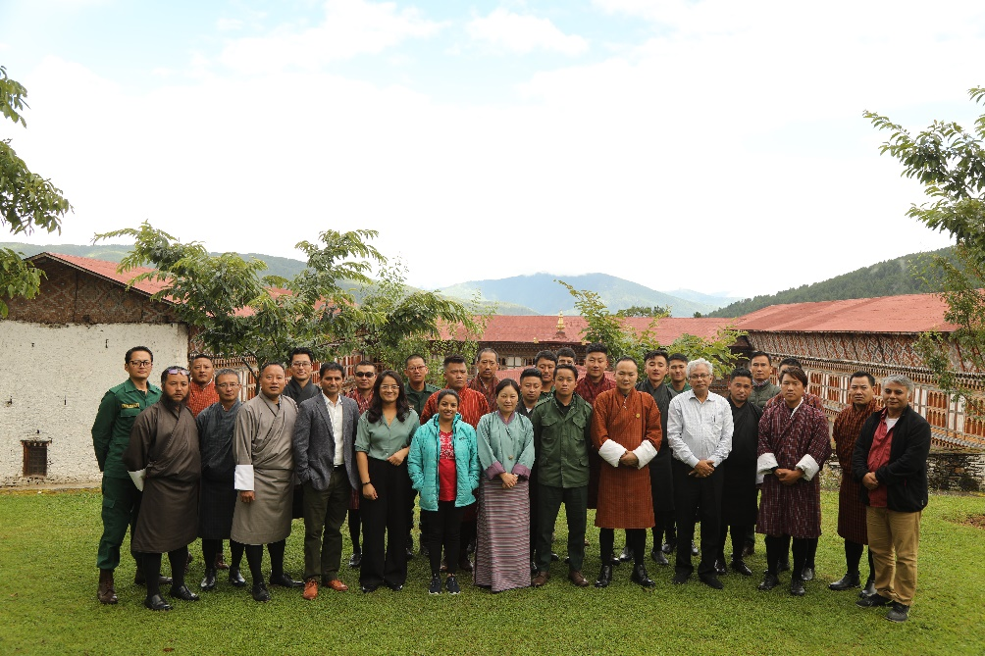
Group Photo with all the participants and resource persons

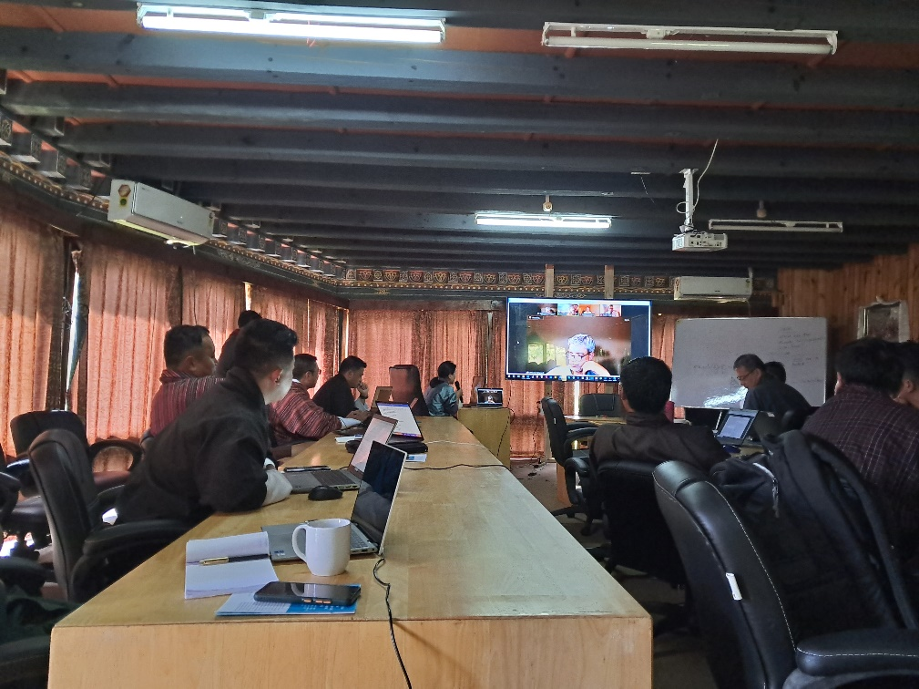
Online session from Prof. Subhrendu Pattanayak
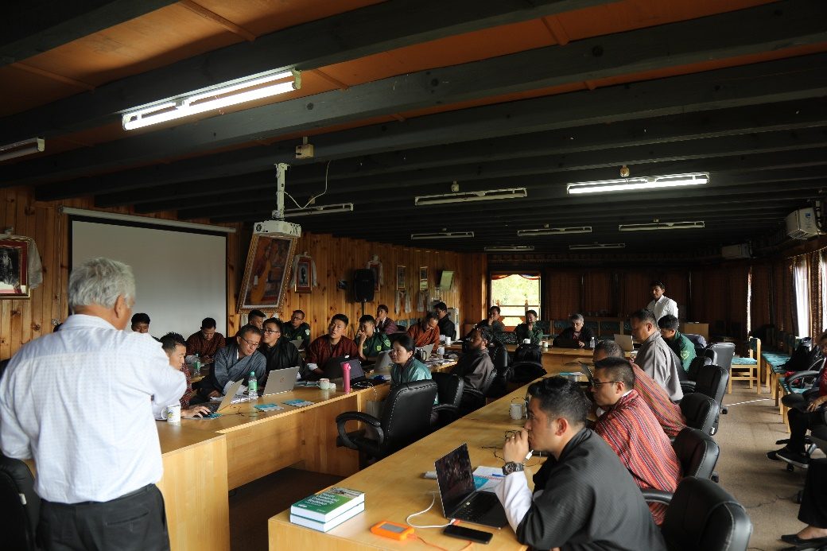
Session by Prof. A.K. Enamul Haque

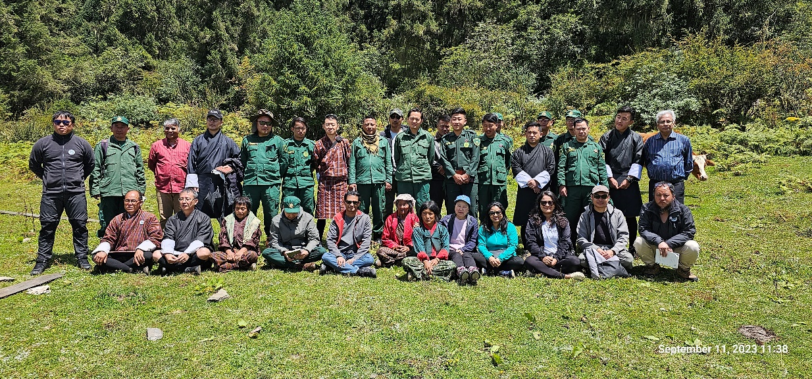
Group Photo after the field visit to Sacred Forest Grove, Shingyeer village, Ura Gewog

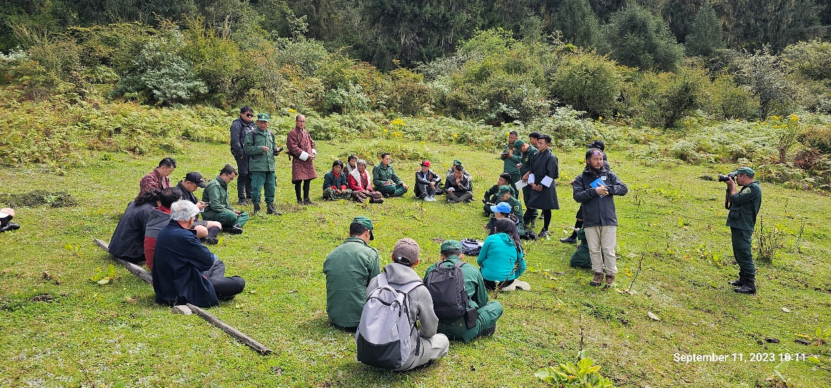
KII on the Sacred Forest with the community leader of Shingyeer Village

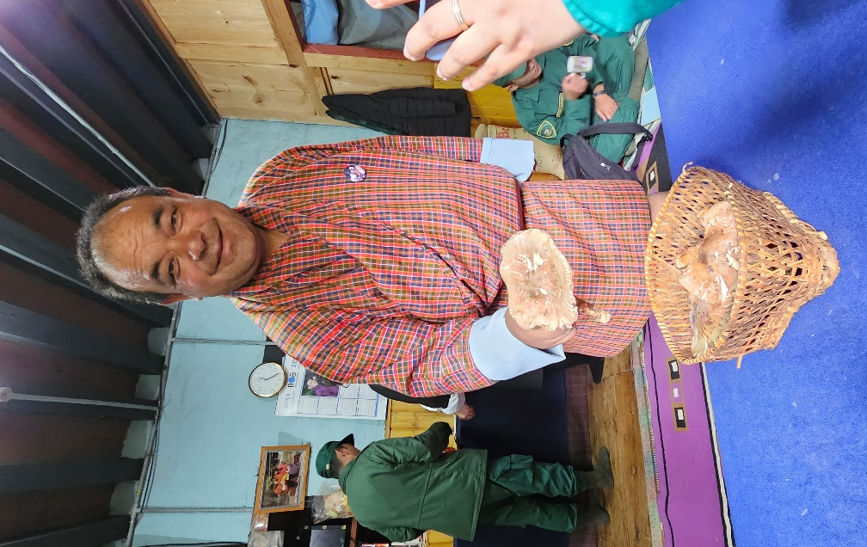
Visit to Ura Mushroom Group

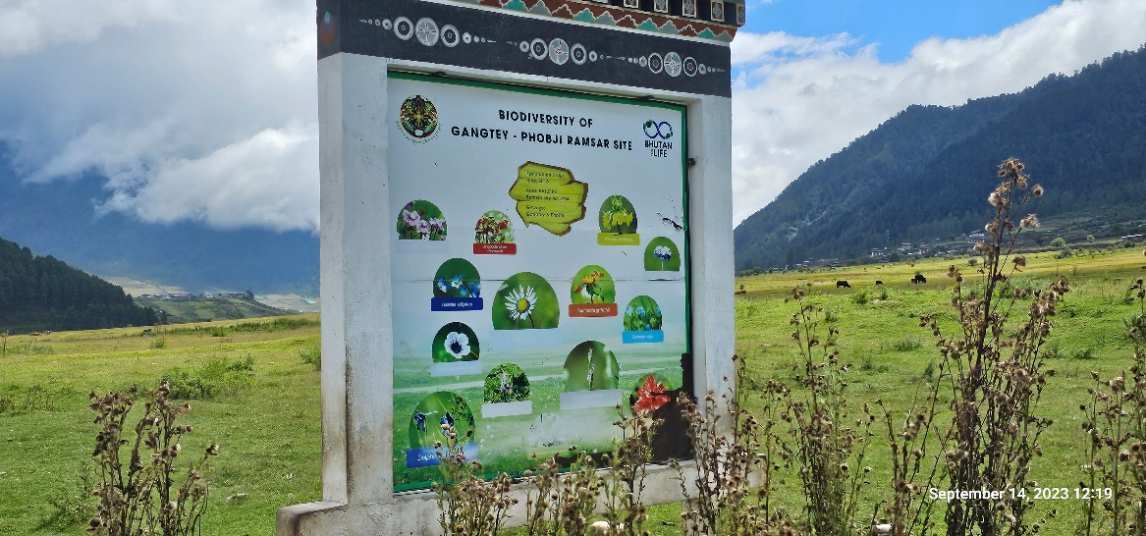
Visit to Gangtey-Phobji Ramsar Site on our way back

